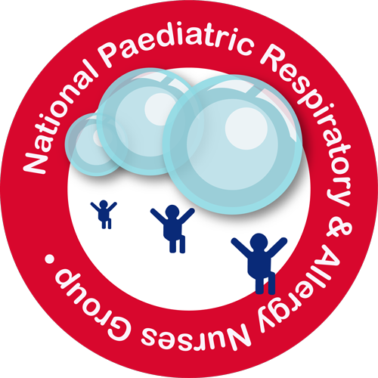

National Paediatric Respiratory and Allergy Nurses Group (NPRANG) Annual Conference Registration Form
Saturday 10th November 2018

Conference Registration Fees

Early Bird Rate: £70 before and including 20th July 2018
Full rate: £100 on or after 21st July until 20th September 2018

Rate includes: Full day conference including refreshments on arrival, breaks and hot 2 course lunch.

To be held at:

Liverpool Marriott Hotel, 1 Queen Street, Liverpool, L1 1RH

Payment to by BACS to:

National Paediatric and Respiratory and Allergy Nurses Group (NPRANG)
Sort code 01 05 51
Account number 40611256

If unable to pay by BACs please contact Claudine.bryson@nhs.net to discuss.

Please note
• No places can be secured for the conference unless the appropriate registration accompanies the application form.
• Invoices will only be issued upon receipt of your Trust’s Purchase Order number but places cannot be guaranteed until invoices have been paid. Please provide purchase order details.
• If payment has not been received from any delegate or her/his Trust, by 20th September 2018 then the delegate will be expected to pay the full registration fee and then claim this back.

Cancellations
Standard 25% cancellation charge applies if cancelled up to eight weeks prior to the event. 100% cancellation fee if cancelled within 8 weeks of the event.

Delegate Details

One Form per person, please reply on line with reply attached to Claudine.bryson@nhs.net

Full Name

Job Description

Place of Work

Address for Correspondence

Postcode

Email

Mobile

Special Dietary Requirement

Method of payment

(Claudine) Rebecca Bryson
NPRANG Treasurer
Paediatric Asthma and Allergy Nurse Specialist
Wirral University Teaching Hospital
Arrowe Park
Upton
Claudine.bryson@nhs.net

