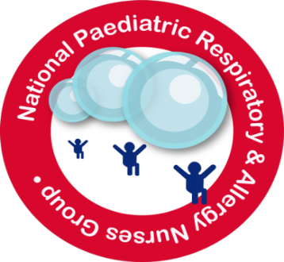

Conference Programme Saturday 10th November 2018
8.45 – 9.15 Registration
Morning session Chair - Anita Critchlow (Chair)
9.15 – 9.20 Welcome – Anita Critchlow (NPRANG Chair)
9.20 – 10.00 Remote DOT, lessons learned on adolescent adherence – Lesley Kennedy
10.00-10.15 Component testing in a nutshell – Roisin Fitzsimons, Allergy Consultant Nurse, Service Lead for Allergy Quality, Patient Experience and Transformation, Guy's and St Thomas' NHS Foundation Trust
10.15 – 11.15 Cough/ bronchiectasis/ PBB [title TBC] – Professor Mark Everard
Professor of Paediatric Respiratory Medicine, Paediatrics & Child Health, Perth, Australia

11.15– 11.45 Coffee and Exhibition Stands.

11.45 – 12.20 Psychological support in difficult to control asthma –
Dr Rachel Calvert, Principal Clinical Psychologist, Sheffield Children’s

12.20 - 1.00 Asthma and Food Allergy - Dr Deborah Marriage
Lead Nurse for Paediatric Allergy, Bristol Royal Hospital for Children
1.00 – 1.50 Lunch
Afternoon session Chair – Ann McMurray (Vice Chair)
1.50 – 2.20 Poster viewing - Poster Exhibitors to answer questions
2.20 -2. 30 Prize Winning Posters – Asthma -Julia Neal, Director of Education, EFH
Allergy – Roisin Fitzsimons, Allergy Academy
2.30 – 2.45 1St Poster Prize Presentation - Asthma
2.45 -3.00 2nd Poster Prize Presentation - Allergy
3.00 – 3.40 Respiratory Physiology – More than just spirometry –
Philip Lawerence, Physiologist, Alder Hey Children’s Hospital, Liverpool
3.40 – 3.50 Coffee
3.50 – 4 20 Paediatric Respiratory Competencies- where are we now?
Viv Marsh, Education Lead, Education for Health
Ana Marote, Paediatric Asthma CNS, Whittington Health NHS Trust
4.20 – 4.30 NPRANG Business and Close – Anita Critchlow (Chair)

